***Name- Harsh Singh Yadav***

***Intern ID- 16052***

***SQL Developer Task - 2*: *Advanced Queries with Joins and Filtering***

**Objective:**

The objective of this task is to analyze relationships between multiple tables using SQL joins and filtering techniques to extract meaningful insights from the data. This task builds upon the `StudentManagement` database created in Task 1 and introduces two new tables: `Courses` and `Enrollments`.

**Project Steps**

**Step 1: Database Setup**

**Tables to Create:**

**1. Students Table (Already Created in Task 1):**

**2. Courses Table:**

**3. Enrollments Table:**

**Step 2: Create Tables and Insert Sample Data**

**Create Courses Table and Create Enrollments Table:**

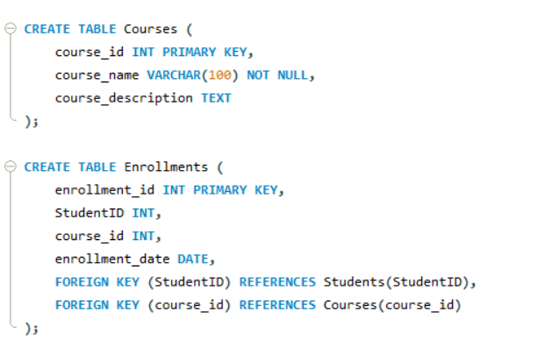

**Insert Sample Data into Courses Table AND Insert Sample Data into Enrollments Table:**

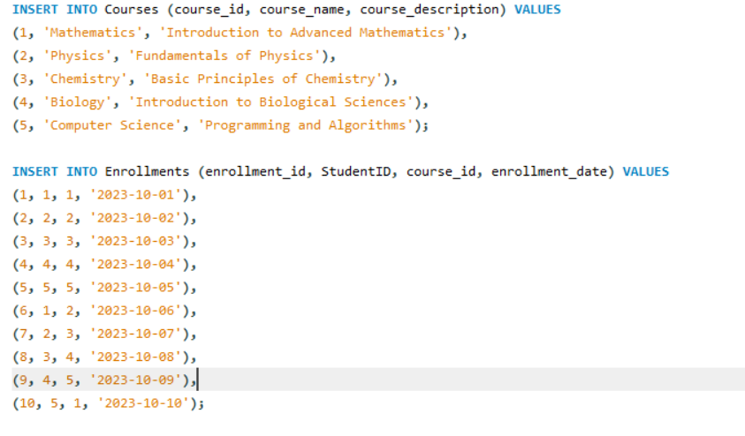

**Step 3: Tasks to Perform**

**Task 1: List All Students and the Courses They Are Enrolled In**

**Query:**

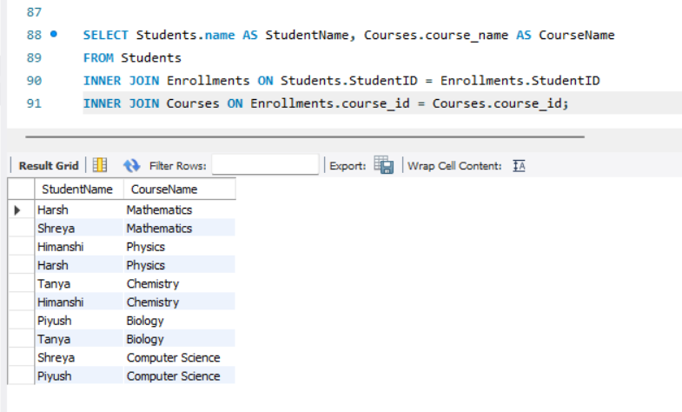

**Purpose:**

This query retrieves the names of students and the courses they are enrolled in by joining the `Students`, `Enrollments`, and `Courses` tables.

**Observation:**

The result will display a list of students along with the courses they have enrolled in.

**Task 2: Find the Number of Students Enrolled in Each Course**

**Query:**

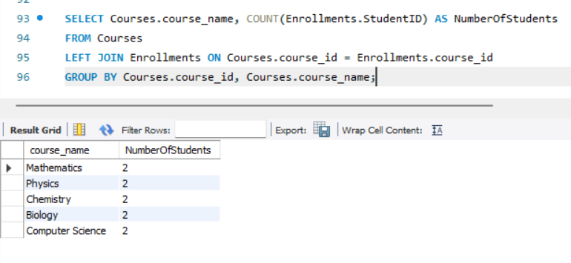

**Purpose:**

This query calculates the number of students enrolled in each course. It uses a `LEFT JOIN` to ensure that courses with no enrollments are also included in the results.

**Observation:** The result will show the course names along with the number of students enrolled in each course. Courses with no enrollments will display a count of 0.

**Task 3: List Students Who Have Enrolled in More Than One Course**

**Query:**

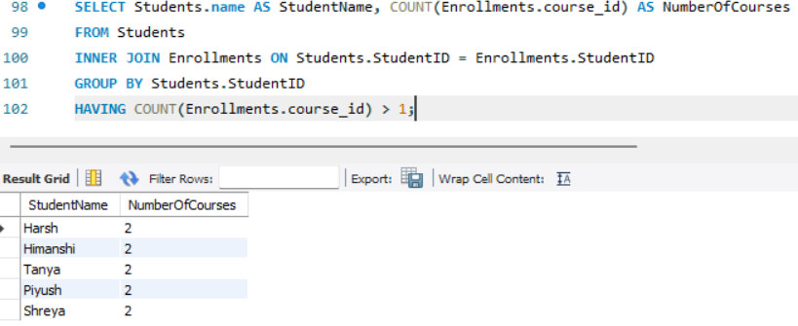

**Purpose:**

This query identifies students who have enrolled in more than one course by grouping the data by `StudentID` and using the `HAVING` clause to filter students with more than one enrollment.

**Observation:**

The result will display the names of students who are enrolled in more than one course along with the number of courses they are enrolled in.

**Task 4: Find Courses with No Enrolled Students**

**Query:**

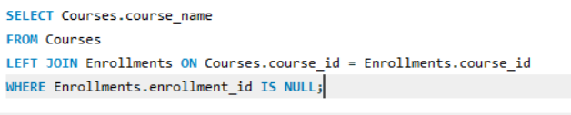

**Purpose:**

This query identifies courses that have no enrolled students by using a `LEFT JOIN` and filtering for courses where the `enrollment_id` is `NULL`.

**Observation:**

The result will display the names of courses that have no students enrolled.

**Conclusion**

This task provides hands-on experience in working with multiple tables, using SQL joins, and applying filtering techniques to extract meaningful insights. By completing this task, you will gain a deeper understanding of how to analyze relationships between tables and generate actionable insights from the data.